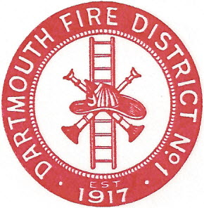
Dartmouth Fire District No.1
10 Bridge Street • Dartmouth, MA 02748
Telephone (508) 996-1596 • Fax (508) 984-4521

Agenda for October 10, 2018 @ 6:30 PM

- Vendor Warrant
- Payroll Warrant
- Equipment maintenance
- Building maintenance
- Sale of International fire engine
- Insurance; Hub International policy and insurance for fuel tanks
- 2018 Audit and Free Cash Certification
- STAT Ambulance contract
- Old Fire Station on Bridge Street
- Meeting Minutes to approve; September 12, 2018
- Gasoline- credit card
- Adjourn

